Ideation Phase Empathize & Discover

Date | 9 February 2026
Team ID | LTVIP2026TMIDS78241
Project Name | LearnHub — Online Learning Platform (OLP)
Maximum Marks | 4 Marks

Empathy Map Canvas:
An empathy map is a simple, easy-to-digest visual that captures knowledge about a user’s behaviours and attitudes.
For the LearnHub OLP, this tool helps the team better understand key users such as students (like Sarah) and instructors (like John), enabling design decisions that improve the overall learning and teaching experience.
For LearnHub, creating an effective platform requires understanding the true problems faced by learners and instructors. The exercise of creating the map helps participants consider things from the user’s perspective — whether that is a student like Sarah navigating course discovery, or an instructor like John seeking better engagement metrics — along with their goals and challenges.

Example:

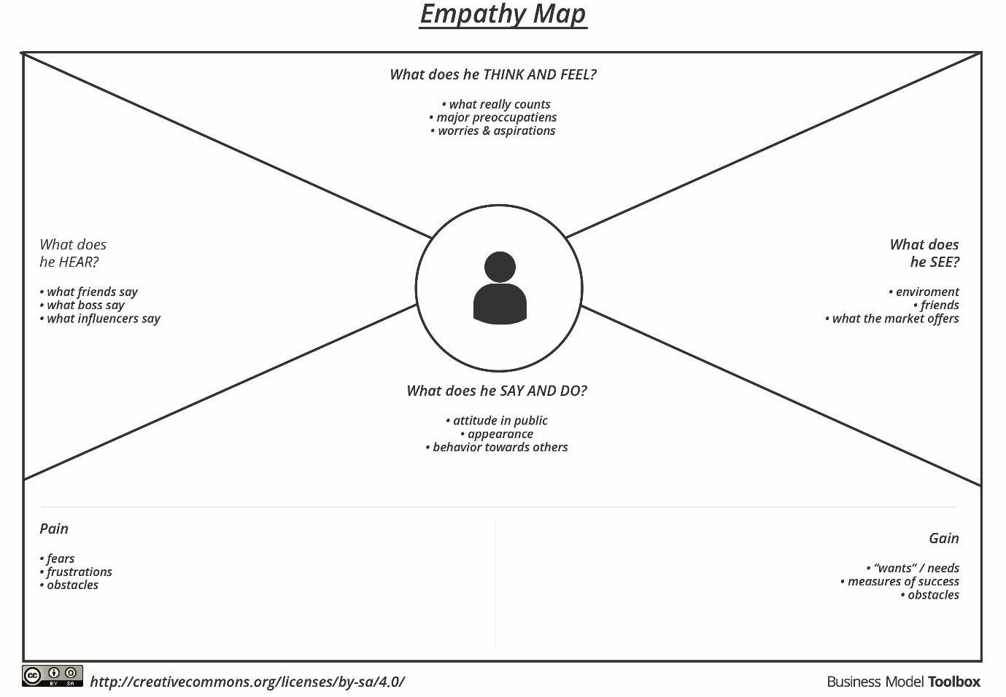

Reference: https://www.mural.co/templates/empathy-map-canvas

Example: LearnHub Online Learning Platform (OLP)

